Arpanet Logistical Decisions

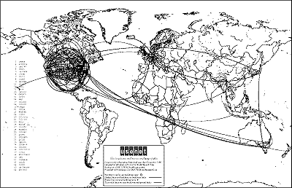

Figure 1 A geographic map of USENET sites and routes from December 1986
Here are the four basic principles for connecting to the Internet:

- Each distinct network would have to stand on its own and no internal changes could be required to any such network to connect it to the Internet.

- Communications would be on a best effort basis. If a packet didn't make it to the final destination, it would shortly be retransmitted from the source.

- Black boxes would be used to connect the networks; these would later be called gateways and routers. There would be no information retained by the gateways about the individual flows of packets passing through them, thereby keeping them simple and avoiding complicated adaptation and recovery from various failure modes.

- There would be no global control at the operations level.

Packet Movement and Verification

- Algorithms to prevent lost packets from permanently disabling communications and enabling them to be successfully retransmitted from the source.
- Providing for host to host "pipelining" so that multiple packets could be en route from source to destination at the discretion of the participating hosts, if the intermediate networks allowed
- Gateway functions to allow it to forward packets appropriately. This included interpreting IP headers for routing, handling interfaces, breaking packets into smaller pieces if necessary, etc.
- The need for end-end checksums, re-assembly of packets from fragments and detection of duplicates, if any.
- The need for global addressing
- Techniques for host to host flow control.
- Interfacing with the various operating systems
- There were also other concerns, such as implementation efficiency, internet work performance, but these were secondary considerations at first.

