Circuit Elements

Battery  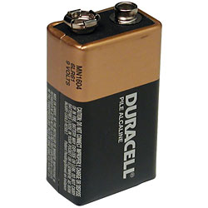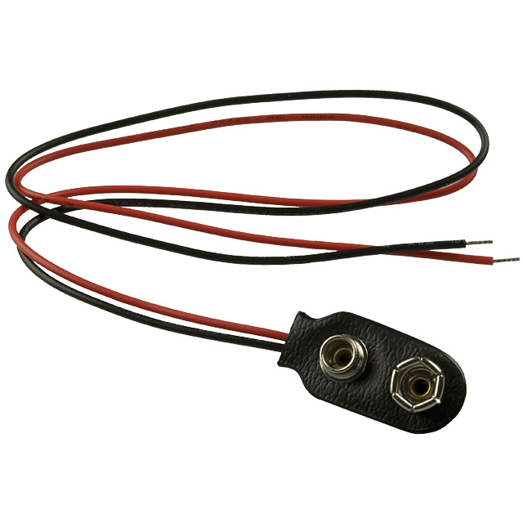 |  | Resistor  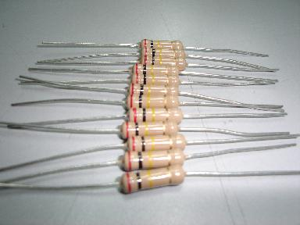 |  | Light Emitting Diode (LED)  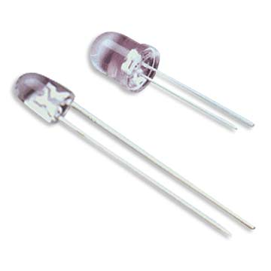
red wire | black wire |  |  | long lead | short lead
+ | - |  |  | anode | cathode
 |  |  |  | + | -
Capacitor  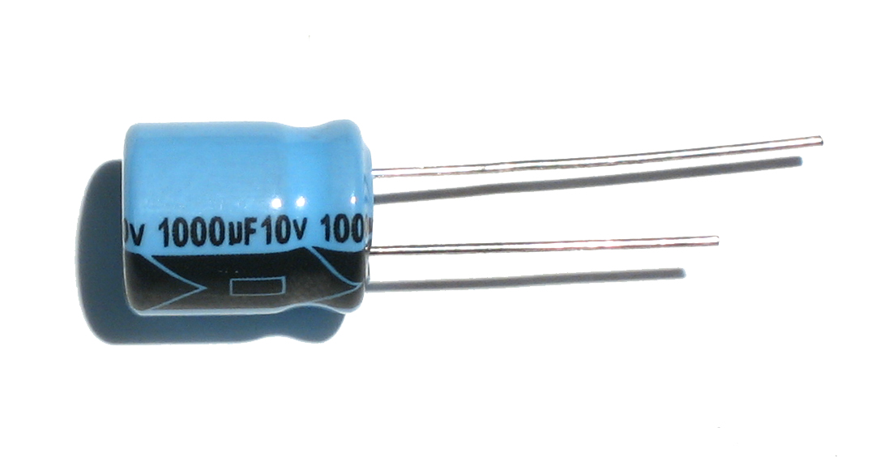 |  | 555 Timer  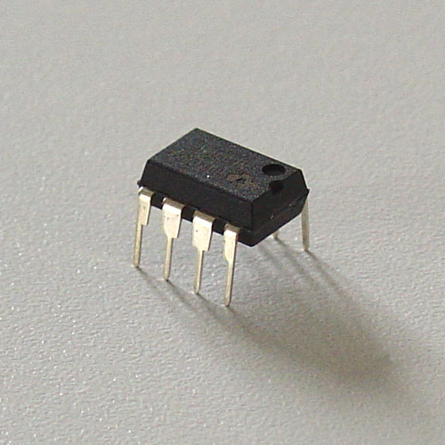
long lead | short lead
no stripe | stripe
+ | -

Light Emitting Diode (LED) Circuit

555 Timer Circuit

