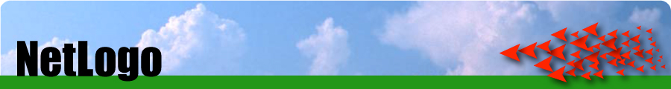

NetLogo Tutorial: Modeling Epidemic Spread

This tutorial describes the construction of an agent-based model of simple epidemic spread for a closed population in which individuals move around and interact, and the disease is spread between individuals based on their interactions. This document describes the steps of planning, building and coding this model, as well as setting up a plot of the numbers of people in different states over time.

For a more in depth introduction to the NetLogo software, or if at any point you feel that details have been left out of these instructions making it difficult to know what you should do, please refer to the NetLogo Introduction document.

This model will be built using the NetLogo modeling tool, which provides an intuitive graphical user interface for building simple agent-based models using the Logo programming language. The software and information can be obtained from the NetLogo website, as well as a Wikipedia entry. Among the resources available at the NetLogo website are tutorial movies covering some of the basic functionality, full software documentation, trial version download, and an online store where you can purchase a license to unlock the full version of the software.

Infectious Disease Introduction

Infectious disease presents a threat to human health directly, as well as to the agricultural livestock and crops that we raise. Regardless of whether disease spreads to individuals from a common source, through some other host, or from individual to individual, epidemics are generally measured and analyzed through an epidemic curve which plots the number of occurrences of the disease (reported or confirmed cases or deaths) over time.

Figure 1 below presents two examples of epidemic curves, from different disease outbreaks. The curve on the left reports weekly deaths (yikes!) from bubonic plague in London around 1666. The curve on the right shows the monthly confirmed cases of measles in New York City around 1962. In both cases you see that the number of cases rises to some peak level and then falls. If you think about a flu outbreak at your school, or in your community, do you think that an epidemic curve for that would look similar? Why do you think so? What accounts for the shape of these or other epidemic curves? What might people do to reduce the number of individuals affected by such an epidemic?

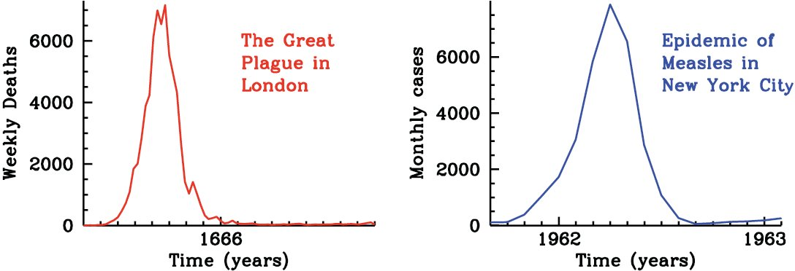

Figure 1: Epidemic curves presenting the number of deaths or reported cases from two different disease outbreaks, from [1]

You may believe that you have good answers to these questions, however if lives depend on the answer, it is important to test the quality of these answers and see if we can find better answers. For scientists, health professionals and governments wanting to minimize the impacts of infectious disease, it doesn’t usually make sense to study disease spread by starting an outbreak. More often disease spread is studied through the use of models that represent our understanding of how the disease spreads.

Using models to study disease spread can have many advantages in that the model properties can be changed to study how disease might spread in different situations, for example if the population was larger, or a vaccine was introduced, or sick people were isolated from the rest of the population. However, in order for these models to provide useful information they have to provide a fairly accurate representation of how a disease spreads in the first place. This means that the model must be able to account for the patterns of disease spread observed in actual outbreaks.

This tutorial will take you through the construction of a model of disease spread in a small population where the disease is transmitted from person to person. An agent-based approach will be taken in which we will concern ourselves with the individuals in the population, and the rules that govern how and when people become sick. An important question to answer in building such a model is whether our understanding of the mechanism, or rules of cause and effect at the individual level are necessary and sufficient to account for the behavior of the system as a whole.

Model Planning

Before starting to work with a modeling tool on the computer it is important to do some thinking and planning about the components and behaviors of the system to be modeled. In the case of an agent-based model it is necessary to think about how many different types of individuals there are in the model, and the rules that govern their interactions. Can individuals change their state based on things they encounter in the simulation? What are the rules that govern these changes?

A reasonable place to start model planning is with ones own personal experience or knowledge. While it may not be pleasant to think about the last time you had the flu, telling a story of your experience is a good starting point. Most likely you had been feeling fine, then, after having contact with somebody who was sick, you became sick. After a couple days of feeling lousy you started to feel better, and eventually you were healthy again; hopefully, for a good long time. We can generalize this story into something like:

Sometimes, when a healthy person interacts with a sick person, the healthy person becomes sick. Eventually sick people become recovered.

From this story we can identify the agents that will be needed in the model as the nouns in the story:

Sometimes, when a healthy person interacts with a sick person, the healthy person becomes sick. Eventually sick people become recovered.

We will need to decide whether recovered people are distinct in any way from healthy people. For the purposes of this model assume that recovered people can no longer become sick.

In NetLogo a couple of other agents are usually needed that serve similar roles in any model. These are the “background” and the “counter” agents. The background agent is the tile floor for the virtual world of the model. It defines the extent of this virtual world where the other, functional agents can do what they do. The counter agent keeps track of how many of the other types of agents are in the model, as well as other similar tracking and control type functions.

Agents:
- Healthy people
- Sick people
- Recovered people
- Background
- Counter

Agents in the model are only able to follow simple rules of the form:

If some condition(s) is (are) true, then take some action(s)

This form of rule is among the most common ways that people use to give instructions to computers. This is an If-Then statement, or more generally a conditional operator. NetLogo, or a number of other computing tools, will often proceed by checking a number of statements like this and for each one evaluating whether the specified condition is true, and if so, carrying out the specified action.

For the purposes of modeling disease spread, our agents will need to move around and interact, but not all of the interactions will be important. Consistent with the description above, the agents can be given the following rules that will govern their transition from one state (healthy, sick, recovered) to another.

Transition rules:
- Action: Healthy become sick
  - Condition: Sometimes, when healthy is near sick
- Action: Sick become recovered
  - Condition: Eventually

Having thought a bit about the functionally important agents and behaviors that our model should include, now we can open NetLogo and begin modeling.

The NetLogo Interface

Creating the Model

Create the project
If you haven’t done so, go ahead and open the NetLogo software. Begin by saving your (currently empty) model by selecting “Save” from the File menu. Use the dialog box that opens to navigate to a directory where you want to place your project. Besure to select a location where you have write privileges on your computer (usually your desktop area is a good choice), otherwise you will experience a large amount of frustration when your model disappears when you close NetLogo. Give your file a name and click the “Save” button.

Setting up Your Model

Setup
Right now you have a completely bare model, with nothing happening. The first thing you need to do is to set up your model – i.e. to generate the initial agents and load all the rules for them to move and interact. Create a setup button by clicking Add, specifying a Button, and clicking anywhere on the view area. When a dialog box appears, set the command for your button to “setup” without quotes. Then, press OK.
Now let’s click on the setup button to start the model. What happened? Why? So far, we’ve told NetLogo to setup, but we haven’t told it what setup means or what it should do to setup. NetLogo marks a command it doesn’t understand in red to indicate that you still need to do some more coding. To start adding substance to your model, click on the Procedures tab. This will take you to the “behind the scenes” for your model, where all of your code will go.

Coding a Procedure
To start off, we need to tell NetLogo how to “setup”. The code for this, naturally enough, is “to setup”. Now, when you press enter your cursor should be indented 2 spaces on the next line. This tells you that you are currently writing within the method “setup”. Any code you type here will be executed by Netlogo when you tell it to setup.
The first command you should always include under Setup is something called “clear-all”. This basically tells the program to delete all agents and remove all attributes, colors, etc from the previous run. It’s good practice to include this in every setup method so that you don’t clutter the screen with a new crop of agents every time you reset the model.
Now let’s consider what other commands to give NetLogo. Presumably, you want to setup all of your agents (called “turtles” in NetLogo lingo), so the next command you should write is “setup-turtles”. For now, that’s the only other command you need, so just end your model by typing (what else?) “end” on the next line. As you type, it will automatically de-indent itself, indicating that the method is at an end.

Setting Up Turtles
Try to execute your code as it now stands. Are there any problems? Why do you think so? As you probably noticed, in the previous section we didn’t define what “setup-turtles” meant, so the computer is still confused. Naturally, now we have to create another method called “setup-turtles” so NetLogo knows what to do.
First, write “to setup-turtles” on a new line and press enter; as before, your cursor should be indented to let you know that you’re in a method. The first thing we want to do is to create some turtles. To do this, simply type “create-turtles” followed by a number. Then, end your method so you can see what this command does.
Now go back to the Interface tab and press setup. What happens? Where were your turtles generated? Right now, our setup function is creating turtles all right, but it’s not doing anything else with them. As a result, NetLogo just applies all of the defaults to them – position in the center of the screen, default shape, and random color. If we want something different, we’ll have to define it ourselves.

Function Blocks
NetLogo has a somewhat weird way of defining the qualities of turtles. Rather than writing a command to the effect “give all turtles some quality”, instead you have to write “ask every turtle to give itself some quality”. Although this can be confusing at first, it makes more complicated functions a lot easier.
Go back to your procedures tab and look at your “setup-turtles” method. When you create new turtles, the easiest way to give them certain qualities is with a function block. At the end of the “create-turtles #” line, add an open bracket “[“ to start your function block, and then press enter. Now you will see that your cursor is indented even more, telling you that you are in a function block within a method. Inside this function block, you can now add all of the rules you want your turtles to apply to themselves.
The first thing you might want to change is location – it’s boring to have all the turtles always start in the middle. To do this, you can add the line “setxy random-xcor random-ycor” to your function block. Basically, this line tells each turtle to set its x- and y-coordinates, or location, on the view window to be random. The random-xcor and random-ycor quantities are special functions that automatically return a random number depending on the size of the viewscreen, so you don’t have to find the random number yourself.
Now you probably want to set the shape of the turtles to something other than the default flying V. The way to do this is very intuitive, simply type “set shape” and then type the shape you want (chosen from a list of default shapes) in quotes. For instance, if you wanted person-shaped turtles, you could type “set shape “person””.
Next we have to set the color of the turtles. It is very important that your colors agree exactly with what is written here, because we are going to use the colors later on to help us decide who is sick and who is healthy. The normal way an epidemic model starts is with all but one person healthy, so you can type “set color green” to make all of the turtles green.
Making the sick person is a bit different, though, because right now we’re dealing with all the turtles, but we only want one of them to become sick. There are two ways we can accomplish this; you can choose whichever makes more sense to you:
Method 1 | Method 2
What we need is a conditional statement that only one of the turtles will fulfill. All of the other turtles won’t have that condition, so they will stay green. Lucky for us, each turtle in NetLogo has a unique ID number, called “who”, so we can simply add the statement “if who = 0 [set color red]”. Basically, this checks each turtle to see if its ID number is 0, then tells the turtle with ID 0 to set its color to red. | What we need is a function block that only deals with one turtle. That way, we can ask that turtle to become red without changing all of the other turtles. The easiest way to do this is to type a closing bracket “]” to end your current function block, and then create a new block by typing “ask one-of turtles [set color red]”. Basically, this asks exactly one turtle (chosen at random) to set its color to red.

Testing your Setup
Now you should have a completed setup method. To test, click the “setup” button you created on your viewscreen. If everything goes properly, you should end up with as many people on your viewscreen as you specified under “create-turtles” scattered randomly around the area. One of them should be red; all the others should be green.
The code you have so far should look something like this:
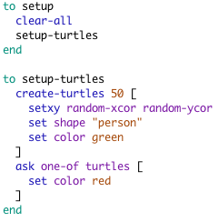

Making Your Model Move

Let’s Go!
Now that we have our initial conditions set, we need to make the turtles move and interact. To do this, we create another button, called “go”. Just like the setup button, we start by setting a command, and then we have to add the coding for that command. The main difference is that we will now check the “forever” box because we want our model to keep going until we tell it to stop. Now, using the same syntax you used for the setup command, try to write your new command under the procedures tab. Think about what parts of the setup command are unique to that command and what parts have to be included for every command.

Fleshing Out the “Go” Command
What do we want our turtles to do when we click go? I.e. what do people do in a disease model? Presumably, our turtles will move around, some of the sick turtles will infect healthy turtles, and some of the sick turtles will recover from their disease. So, just like with our setup-turtles command, we can add lines in the go command for each of these actions. Basically, this tells the program that whenever it executes the “go” command, it is supposed to execute each of the following subcommands – move, recover, and infect.

ASIDE – COMMENTS:
As we work with these commands, we’re going to want to test many of them one by one to make sure they work. The problem is that NetLogo won’t execute a command at all if any of its methods aren’t working. One way to solve this is by commenting out the commands we aren’t interested in. In NetLogo, this is done by putting a semicolon “;” in front of the command. For instance, looking at the following code, can you figure out what NetLogo will do when the method is run?
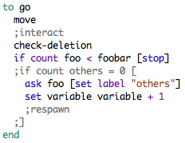
When the above code is run, NetLogo will do the following things:
- Run the “move” command
- Run the “check-deletion” command
- Stop the model if the number of “foo” is less than the variable “foobar”
- Ask each foo to set its label to “others”
- Increase the value of “variable” by 1
NetLogo will skip all of the commented-out lines. Note that by commenting out the lines “if count others = 0 [“ and “]”, we have essentially removed the material in between them from the If-statement. This is a great way to see what would happen if an If-statement were always true.

Move
Generating movement in NetLogo is very easy because it is built into the software. Each turtle comes with a position and a heading, where the position is (x, y) and the heading is a number from 0 to 360, representing the degrees of a circle. To make a turtle move, then, we only need two commands:
- Forward #: tells a turtle to move # spaces in the direction of its heading
- Right #: tells a turtle to turn right # degrees (negative numbers make the turtle turn left instead)
Using these two commands, see if you can make your turtles move randomly. Remember to begin the command with “to move”, end with “end”, and use the “ask” command to apply your actions to all turtles. When you are finished, comment out the “infect” and “recover” commands, then run your model. If it doesn’t execute the way you intended, check out the following list of common problems and solutions:
Problem | Solution
My turtles are moving in circles | Unless the average turn is zero, your turtles will tend to move in circles. An easy way to make sure your average is zero is to setup your code like this:  right random 2x – x  Where x is the maximum turn, in degrees.
ASK expected two inputs, an agent or agentset and a command block | Remember that NetLogo doesn’t know what you want to ask your turtles to do unless you put it in brackets. For an example, see the coding for the setup command.
My turtles are moving too fast/slow | Try changing the number after “forward” to change how fast turtles move (decimals are allowed). Keep in mind, though, that the program will naturally run faster the fewer turtles you have.

Infect
In this tutorial, we’re going to use a very simple method of separating infected from healthy turtles – their color. As we saw in our setup command, one of the turtles is red (sick) and the rest are green (healthy). Basically, we want each healthy turtle that is next to a sick turtle to have a certain chance of becoming sick. You may need the following commands to code this part:
- turtle with []: this command restricts your selection to only those turtles who have the qualities listed in the command block []. For instance, “turtles with [shape = “person”]” returns a set of all the turtles that are shaped like people.
- Any?: this command checks to see if the condition after it is met for any turtle. For example, “any? turtles with [shape = “person”]” is true if there is at least one turtle that is shaped like a person.
- turtles-here: this represents the set of all turtles at a certain location. If you put this inside of an “ask” command block, it will look at all of the turtles near your particular turtle.
- The chance that a turtle is going to become sick is represented by the variable “infectiousness”, which ranges from 0 to 100 and is the percentage chance that a person will become sick.

Recover
The basic idea of this command is to give each sick turtle a certain chance, called “recovery_rate” of changing its color from red (sick) to gray (recovered and immune). Be sure that this command only applies to turtles that are already sick – a healthy turtle can’t spontaneously become immune! You shouldn’t need any new commands to code this part.

Adding the Variables
Right now, even if you did everything perfectly, your model is still going to give an error: Nothing named INFECTIOUSNESS has been defined. Can you think of why you might get that error? The problem is that NetLogo doesn’t know what value you have in mind for infectiousness (or recovery_rate). To tell it, go back to your interface tab and create something called a “slider” by clicking on the drop-down menu labeled “button”. When you insert one of these, you see a pop-up similar to this one:
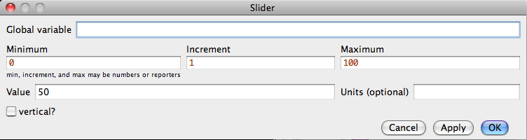
In the box labeled “Global variable”, type in the name of the variable you want to define (either infectiousness or recovery_rate, you’ll do both eventually). Then, you can determine the minimum, maximum, and current values for the variable. Now you will be able to set the value of your variable simply by dragging the slider back and forth. Once you have both variables defined, you should be able to execute your program and have it run successfully. If not, check out a possible solution, listed below:
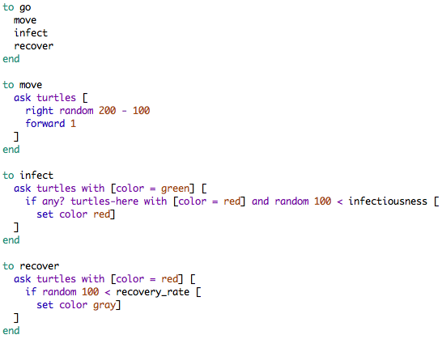

Tweaking your Model

Break Conditions
As you execute your model, you may notice that it continues to run forever regardless of what happens to the population. In reality, though, there’s little point in continuing to let it run once the sickness has died out. To automatically stop it at that point, we can insert something called a break condition.
A break condition is a short statement inserted in the “to go” method that checks to see if a certain condition is true and, if so, stops the command. The general format for a break statement is “if some condition [stop]”. Try to come up with a condition that will test to see if there are no sick turtles left in the model.

The Ticking Clock
Earlier in the tutorial, we noted that the speed of the turtles is not really determined by their speed in the movement command, but instead by the speed at which the computer runs the model. If we want to know how quickly the infection spreads relative to the turtles’ movement, we can use a built-in NetLogo function to count the number of times that the “go” command has run.
The syntax for this function is very simple. In the “go” command, add a new command called “tick”. Then, every time the command runs, the model will add one to its virtual tick-counter, which is displayed on the main screen.

Adding a Graph
As you’ve probably noticed, just looking at the model while it runs isn’t very informative to someone trying to find the peak or measure the infection rate over time. To make things easier, we can add a graph of the various quantities. To do this, go to the “button” dropdown menu again and this time select “plot”. This will bring up a dialog box where you can set some of the main features of the plot. For this tutorial, we will leave “autoplot” checked, so the only things we really need to worry about are the plot title and plot pens.
Name the plot whatever you want, but make sure to note what the name is for your coding later on. In the same way, you can create three plot pens named “sick”, “healthy”, “recovered”, and “total” and give them colors that make sense. When you’re done, click “OK”.
Now we need to create the commands that will update the plot with the numbers of each of these groups. To do this, create a command called “update-plot” that will update each plot pen with the relevant numbers. You may need the following commands:
- set-current-plot “foo”: tells NetLogo that you are dealing with the plot named “foo” right now. This command must be included at the beginning of your update-plot command.
- set-current-plot-pen “foo”: tells NetLogo that you are dealing with the plot pen called “foo” right now. This command is similar to the “ask” command, but you don’t need brackets afterwards.
- count foo: returns the number of foo in existence right now. Note that you can qualify foo. For instance, “count foo with [size = 1]” will give you only the number of foo that have a size of 1.
- plot #: add # as the next entry of the current plot pen. Keep in mind that, while 18 is a number, so is “count turtles with [size = 1]”.
When your command is complete, you need to make sure it is run when necessary. To do this, add the command to both your “setup” and “go” commands. When this is done, your model is complete!

Glossary

Agent – Autonomous individual entities that act, interact and respond to their environment according to a set of prescribed rules. In NetLogo they are called “turtles”.
Agent-based models - Simulation of the simultaneous operations and interactions of multiple agents, in an attempt to re-create and predict the appearance (emergence) of complex phenomena at larger scales.
Local variable (NetLogo) – Agent Attributes are used to specify information about an agent. Unlike Simulation Properties, which are global to the entire simulation, Agent Attributes are local to each instance of an agent.
Background agent (NetLogo) – In NetLogo models Background agents are typically used within worksheets to define the extent of the simulated environment within which the agents behave. Background agents typically have no behaviors themselves, and simply serve as a substrate upon which the behaving agents move and interact.
Behavior (NetLogo) – The behavior of an agent is dictated by the set of rules and methods (see below) found in the Behavior window belonging to that agent. The Behavior window can be viewed or edited by selecting Edit Behavior from the Gallery menu, clicking the Edit Behavior button near the bottom of the Gallery window, double-clicking in the blue area or large depiction of the agent in the gallery window, or control-clicking (right-clicking) the agent and selecting Edit Behavior form the pop-up.
Condition (NetLogo) - Conditions are used to test the circumstances agents are in. Among other things, agents can test for the presence of other agents in the worksheet, attribute values, keyboard input, mouse events and even content of live web pages.
Conditional expression – Features of a programming language which perform different computations or actions depending on whether a programmer-specified boolean condition evaluates to true or false.
Counter agent (NetLogo) - In NetLogo models Counter agents are often used to carry out operations such as keeping track of the numbers of agents of different types in the worksheet, or evaluating conditions that would cause the simulation to be stopped.
Depiction (NetLogo) – Distinct appearances of an agent that reflect the state the agent is in, for example, healthy, sick and recovered. New depictions for an existing agent can be created from the Gallery window or the Gallery menu.
Epidemic curve – A plot of the number of cases of, or deaths from a disease versus time.
Gallery (NetLogo) – The Gallery window contains the agents that have been created for the currently open project and provides tools for creating and editing these agents. The Gallery menu provides an alternative way to access the agent editing tools.
Global variable (NetLogo) – Variables that are used to share information between agents. Unlike local variables, which belong to each turtle individually, global variables are accessible by all agents.
If-then statement – A conditional expression in which a condition is first evaluated to see whether it is true or false. If it is true then the associated action is carried out, otherwise the action is skipped and the next expression or rule is evaluated. All NetLogo rules take the form of if-then statements.
Mechanism – The set of cause and effect relationships between events that is necessary and sufficient to account for natural phenomena.
Method (NetLogo) – A set of rules that is evaluated in response to a particular triggering event.
Necessary and sufficient – In creating a functional model of some phenomenon it is important to consider whether the components (agents, equations, parameters), and structure (behaviors and interactions) are necessary to account for the system’s behavior (i.e. the system doesn’t behave properly without it), or sufficient to account for the system’s behavior (i.e. the model already functions realistically enough without adding more to it). In general the goal is to make the model as simple as possible to account for the phenomenon, if the model is sufficient then don’t elaborate it unnecessarily, if a component isn’t necessary then remove it. The adequacy of a model is typically assessed by asking scientific questions and then using the model to answer the questions.
Rule (NetLogo) – A conditional expression of the form “If condition(s) is(are) true, then carry out action(s)”. Rules are created for each type of agent by double-clicking the blue texture area of an agent box in the Gallery window, by clicking the “Edit Behavior” button at the bottom of the Gallery, or by selecting “Edit Behavior” from the Gallery menu.
Transition – Agents in most dynamic simulations will have behaviors that cause them to change into a different agent or a different agent depiction in response to conditions they encounter in the simulation. At the system level these state transitions are tracked as changes in the numbers of individuals in each category.
Turtle (NetLogo) – The name for an agent in NetLogo, this is used primarily as a shorthand way to refer to agents when writing code.
View (or world, NetLogo) – Worksheets are the NetLogo files in which simulations are constructed using agents found in the Gallery. Various tools along the left side of the worksheet are used for placing, manipulating and querying agents within the worksheet, and controls along the bottom are used to run and reset the simulation.

References

[1] Earn, David J.D. (2008) A Light Introduction to Modelling Recurrent Epidemics, in Mathematical Epidemiology, Fred Brauer, Pauline van den Driessche and Jianhong Wu Eds., Springer-Verlag

