These notes will serve as a guide and reminder of several features in Excel that make the use of a spreadsheet more like an interactive thinking tool. The basic features/options to be explored are:

Views
Naming constants or parameters
Formulas
Interactive controls
Graphs
Iteration
Conditional Formatting
Definitions

View

Sometimes the default view is “Page Layout.” This display divides up the spreadsheet according to how many pages on which it could be printed and displays these pages. “Normal” layout gives you a full, continuous spreadsheet with contiguous names of columns and rows.

Page Layout | Normal Layout
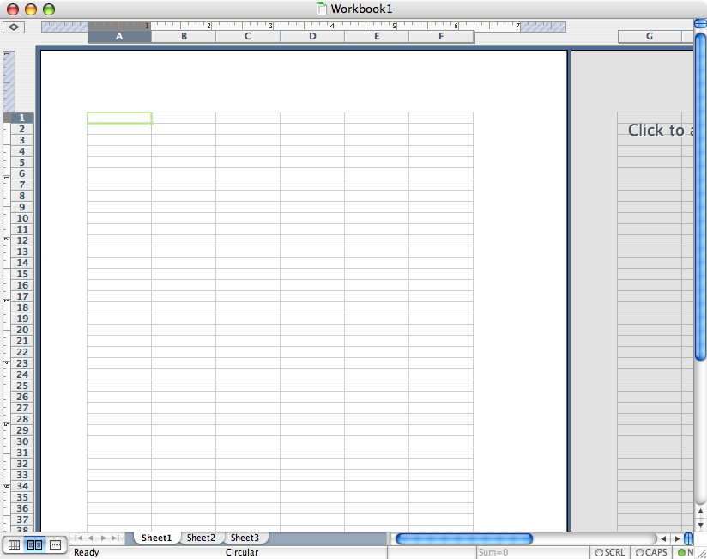 | 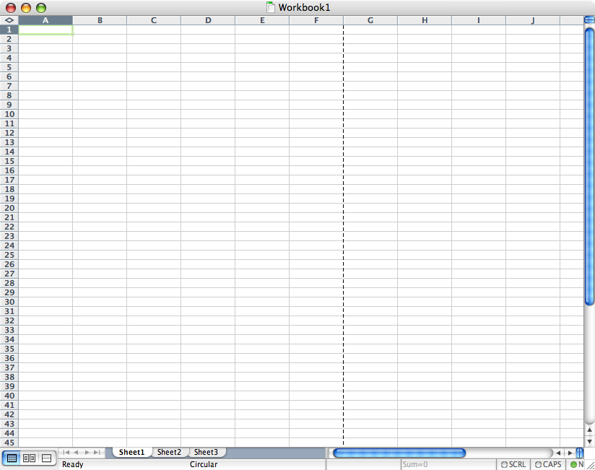

To change the view, select View → Normal in the top menu.

- Adding toolbars -
This is the Standard Bar. Most of the tools on here are fairly familiar (Save, Cut & Paste, etc). There are also shortcuts for things like adding charts.
If you don’t have this, select View → Toolbars → Standard.

This is the Formula Bar. The text box on the left is where the names of cells are displayed, and the text box on the right is where formulas are displayed.
If you don’t have this, select View → Formula Bar.

The Status Bar lets you know what is going on (for instance, when a formula is being calculated in the background). It’s positioned at the bottom of the page.
If you don’t have this, select View → Status Bar.

- Other preferences -
If you need to set other preferences, use the menu selection: Tools → Options (Excel → Preferences on a Mac). Some of these will be demonstrated in class.

Names

Many times it is more helpful to use a word or name to describe a constant in a spreadsheet. It may be easier to refer to a cell by a name like “Interest_Rate” or “Books” or “Percentage” or “Enrollment” rather than “$G$4” or “A7.”The use of a named constant is the same as if you used the absolute reference $Column$Row notation to keep a cell from changing in relative addresses. The use of names often makes formulas easier to understand, remember, and use.

There are two basic ways to name a cell:

Using the menu:
Select the cell you want to name. From then top menu, select Insert → Name → Define. If you have a label “near” this cell, Excel will guess that name. If this is the name you want, just click [OK]. If you don’t have a label, or if you want a different name, type a name then click [OK].

Using the Formula Bar to name a cell:
Select the cell you want to name. Click inside the name box. This will automatically highlight the default name of the cell. Type a name in the name box.* Hit [Enter].

* Remember, there cannot be any spaces in a cell name. Use an underscore for a space.

- Deleting a name -
From then top menu, select Insert → Name → Define. Select the name you want to delete and click [Delete]
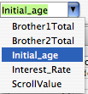
- Jumping to a cell using its name -

← Open the dropdown menu on the name box.
Select the name of the cell where you would like to go.
You may refer to any named cell by its name or by its ColumnRow notation. Named cells can be moved and the name travels with the contents of the moved cell.

Formulas
By default, when you copy a formula into a cell, its value changes in relation to other cells. This is called relative referencing.

Every formula begins with an equals sign (=). This works as a signal to the computer that you are entering a formula.

Formulas look like this:
In order to get this: | Type this:
 | = (Click on B3) / 2
 | = (Click on B3) * 10
 | = (Click on B3) + (Click on C4)
 | = (Click on Interest_Rate) – (Click on D3)

“B3”, “C4” and “Interest_Rate” are all names of cells in the document. You can either type the name of the cell you want to add to your formula, or you can click on it and the name will be automatically added for you.

Hit [Enter] in order to calculate the formula and escape formula mode.

- Copying Formulas -
What if you wanted to apply the same formula to an entire column? Should you type in the value for every cell? That would be very tedious, and thankfully it’s unnecessary.

In order to fill every cell in a column with a formula, click on the bottom right corner of the cell you wish to copy. Drag this corner down along the column, and the formula will be copied into every cell beneath it.

The “IF” function

A tremendous amount of the power of automatic computation is the ability to specify an “IF…Then…Else” branch scenario. If something is true, THEN set the value of the cell equal to one number, ELSE set the value of the cell equal to something else. In Excel, the IF function serves this purpose.

Suppose we had a bank willing to pay 5 percent interest if our bank balance was greater than $1000, or 2 percent if it is less than or equal to $1000.

In a cell, the function would look something like this: =IF(BALANCE>1000,.05,.02)

This has the form: =IF(LOGICAL TEST , VALUE IF TRUE , VALUE IF FALSE)

The “=” in front of the “IF” tells Excel to evaluate this expression, and that it is not just text.

This can be a very powerful thinking tool, and “If” statements can be nested by making the “Value if true” or “Value if false” parts of the function another IF function.

Scroll Bars and Spinners

A scroll bar is used to interactively change the value of a cell and any cells or graphs that depend on the cell controlled by a scroll bar. This allows you to see how the results in a cell, chart, or graph change as the data changes.

A spinner also allows you to increase or decrease the value of a cell, but differs from a scroll bar in not having a slider control “knob”.

From the top menu, select View → Toolbars → Forms

The Forms toolbar will pop up.
From the Forms toolbar, select the “Scroll Bar” button:

Your mouse will change to a thin crosshair. Drag over the area of cells where you would like your scroll bar to be located.* The result should look something like this:

A scroll bar will assign a non-negative integer value to its linked cell. If you want to have a parameter that is not an integer, you will have to build your own parameter by a simple transformation of your linked cell.

Modifying properties of a scroll bar –

Once you create your scroll bar, you still need to tell the scroll bar what information it is modifying. Right click (or [ctrl] click) on the scroll bar.
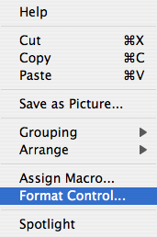

This menu will pop up →

Select [Format Control] from the popup menu.

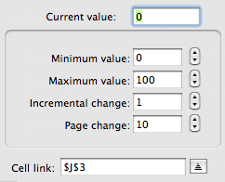
← This window will pop up.

- Current value: value right now
- Minimum value: the lowest setting
- Maximum value: the highest setting
- Incremental change: how much the value will change with one click of the arrow buttons
- Page change: how much the value will change if you click on the scroll bar itself.
- Cell link: the cell whose value will be affected by the scroll bar.

- Linking the scroll bar to a cell -
In the Format Control menu, use the cell link option to tell the scroll bar which cell it is modifying.

Click the button that looks like this:

You will get something that looks like this:

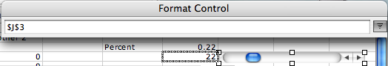

Click on the cell you want the scroll bar to modify, then hit [Enter] or [Return].

If you have named a cell, you can refer to the cell by its name.

- Limitations of a scroll bar -
A scroll bar cannot handle decimals or negative numbers. This means that you have to make your own formula to convert an integer into whatever you need it to be.

In this example, the actual percentage is 0.22. The value the scroll bar is modifying is 22:

Percent = Scroll Value / 100
General formula for a scroll bar with a range of A to B: Set the range on the slider from 0 to 100, choose a cell S for the slider to control, then build a formula in a different cell:
= A +( S/100) * (B-A)

Think of it this way: S/100 is some fraction, so (S/100)*(B-A) is a fraction of the distance from the left end point A of your range (B-A) to the right end point B.

If you want finer granularity, use a bigger value than 100 in both the scroll bar format control and in your corresponding formula.

Note: this “linear transformation” is a powerful skill and an example of both algebraic thinking and algorithmic thinking. Math teachers often find it very useful to have the students carefully think through and reflect on this control feature

Graphs
Graphs and charts help you to visualize information.

Highlight the information you would like to graph
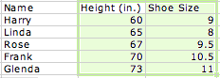

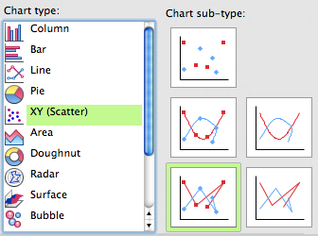
From the top menu, select Insert → Chart

← This is the first menu you will see

Choose the type of chart you want. In this case, we want XY (Scatter) connected by straight lines.
Hit [Next]

The next menu will include something like this. If you want to change what part of the spreadsheet should be included in the graph, click the button on the right, and select the area you want to use.

Hit [Next]

The next menu will allow you to enter a chart title and axis titles. Type in the appropriate information.

Hit [Next] then [Finish]

- Changing the appearance of your chart -
The chart resulting from the previous set of information doesn’t look that good at first:
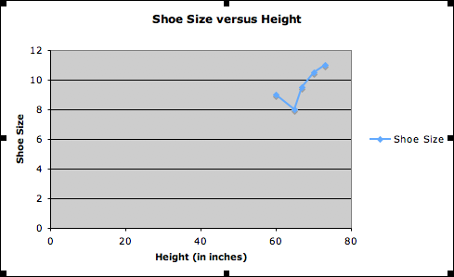

Why is the information squished up in the corner? See how the height and shoe size both go all the way down to zero? If the minimum height and shoe size were bigger, then the chart might look better. In most cases, the default values for the axes and scales are not what you want for your data. You also have to be careful that you present an honest view of the data and not use scale to distort the information content of your data. You can adjust the scales and limits of the axes, as well as control the other features such as gridlines, major and minor tick marks, color, and legend.

Right click (or [Ctrl] click) on the axis. You’ll see a popup like this:

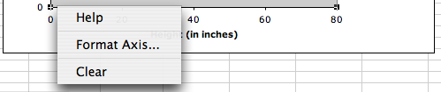

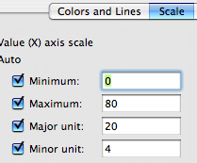
Click [Format Axis]

This menu will pop up →

Select the tab labeled “Scale”

Minimum and Maximum: Determine the limits of the axis
Major unit and minor unit: Determine how the axis will be divided

This is how the chart looked after I set the minimum height to 55 and the minimum shoe size to 6:

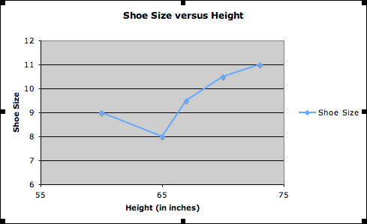
Iteration

In Excel, you sometimes want a “circular reference” which is normally not allowed. An example would be a formula for a cell that refers to itself, or two cells that refer to each other.

Use the menu selection: Tools → Options (Excel → Preferences on a Mac). Selection “Calculation”. You need to choose Manual instead of Automatic calculation. We’ll do a simple counting example in class to demonstrate how this could be useful.

Conditional Formatting

Sometimes you want to use a visual cue to help your eye “spot” important data conditions. By using conditional formatting you can change a cell’s font color, pattern, or background color based on the value of the cell itself. For example, suppose you wanted to take a table of grades and make it easy to spot high and low grades. Consider the starting table:

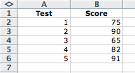
In this example, there are five test scores, and one of them is below 70, and two of them are above 90. Our goal is to make it easier to “see” this right away by coloring the cell, for instance, yellow to signal a caution for a low score, and green to signal good work for a high score.

Start by selecting the cells to be “conditioned” by selecting cells B2:B6. Then, from the FORMAT Menu, select Conditional Formatting:

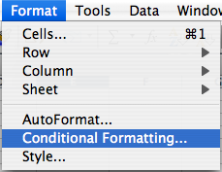

and this menu will appear →

You will then get a dialog box in which you have to select a logical comparison rule indicating the cell value is equal to, less than, greater than some set value, or whether the cell value is between two values that you specify.

You can have up to three conditions tested for the selected cells. In our case, we want to color the cells differently if they are above or below some specified value. Once you specify the rules, click on the format button to change the font color or pattern. For the sample grades example, there are two rules, which would appear as follows:

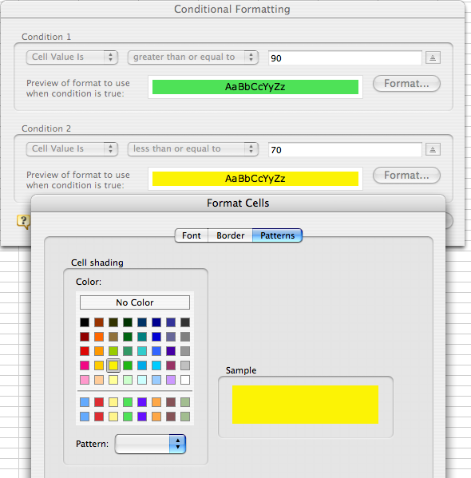

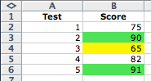
After clicking “OK” the cells are now tested and assigned their various colors. These colors are dynamic; if the values in the cells change, the colors would also change as long as the conditional formatting is in effect. You can delete or change rules following the same procedure as described here to create the rules.

- Definitions -
Spreadsheet | A rectangular grid for storing information
Cell | Rectangular divisions in a spreadsheet. Data is entered in cells.
Column | Vertical lines of cells. (Labeled by letters)
Row | Horizontal lines of cells (Labeled by numbers)
Scroll bar /  Slider bar | A tool which can change the value of a cell by regular increments
Relative Reference | Referencing a cell so that when a formula is copied from one cell to another, the name of the cell changes relative to the location of the cell the formula is copied into.
Absolute Reference | Referencing a cell so that when a formula is copied from one cell to another, the name of the cell DOES NOT change relative to the location of the cell the formula is copied into. Naming a cell creates an absolute reference.

Recommended reference:

Spreadsheet Tools For Engineers Using Excel: Including Excel 2002
by Byron S. Gottfried

